**Ganpat University**

**Faculty of Engineering & Technology**

**Computer Science & Engineering**

**(2CSE204) Basics of Operating System and Shell Scripting**

Name:- Dwij Vatsal Desai

Sem:- 2

Sub: - BOSS

Enrollment No.:- 23162121027

Prac:- 2

Date:- 20/2/2024

**Practical 2**

1. Create a Directory named **India** with subdirectories *Gujarat, UP, Rajasthan and Delhi*. All these 4 directories must be created along with **India** only. Each subdirectory contains three files with names *stateX* (where state is state's name and X is 1 to 4).

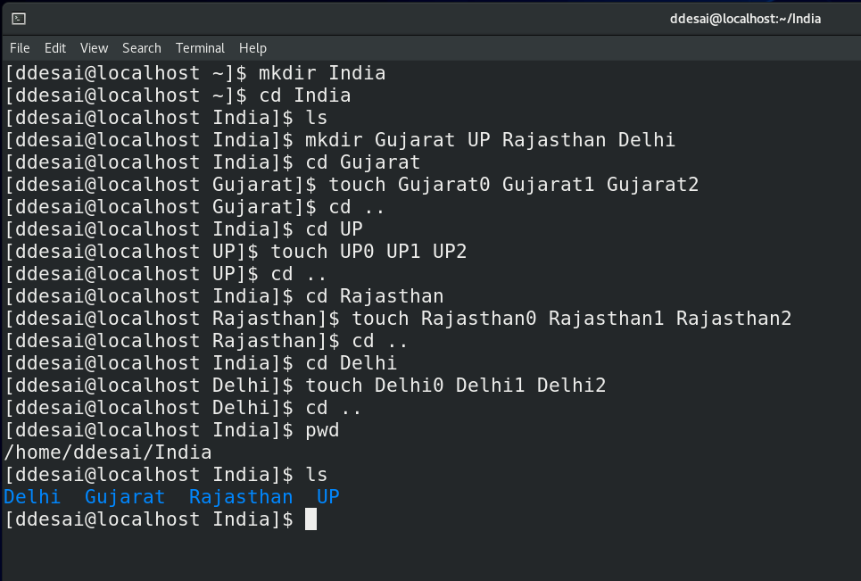

1. One more directory Delhi_Copy contains files copied from the Delhi directory.

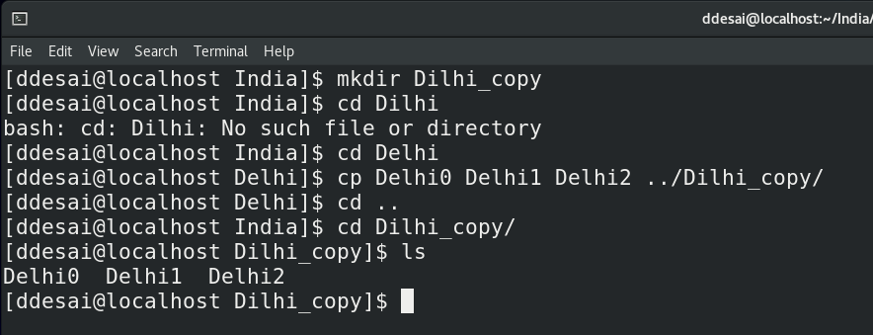

1. One more directory Gujarat_Move contains the files moved from Gujarat directory.

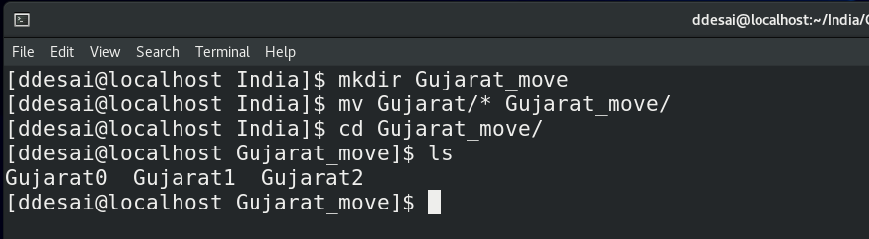

1. UP and Rajasthan directories along with their internal files should be copied to /tmp directory

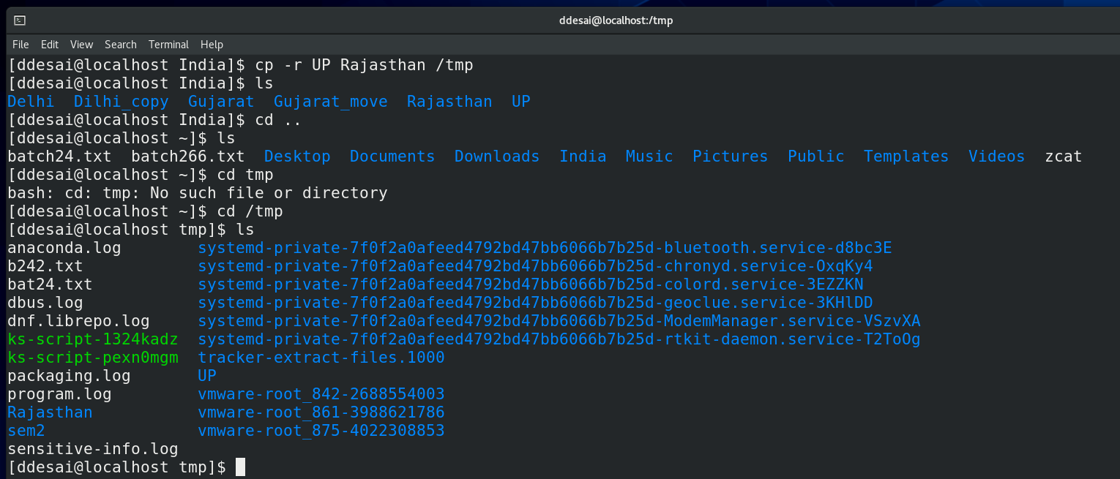

1. Entire India directory should be removed without removing individual subdirectories and files.

